Here is the process to register SonarQube as a producer and then register SonarQube controller (developed by *Solutions and Integrations* team) as a consumer.

Step 1: In order to register SonarQube as a producer to Event Fabric one need to send a post request to Event Fabric using the Swagger UI. Please see the details below:

* Visit the URL: http://service-manager-test.caas-dev.ca.com/eventfabric/api/swagger-ui.html
* Click on **Producer Registration**from the webpage as shown below:  
  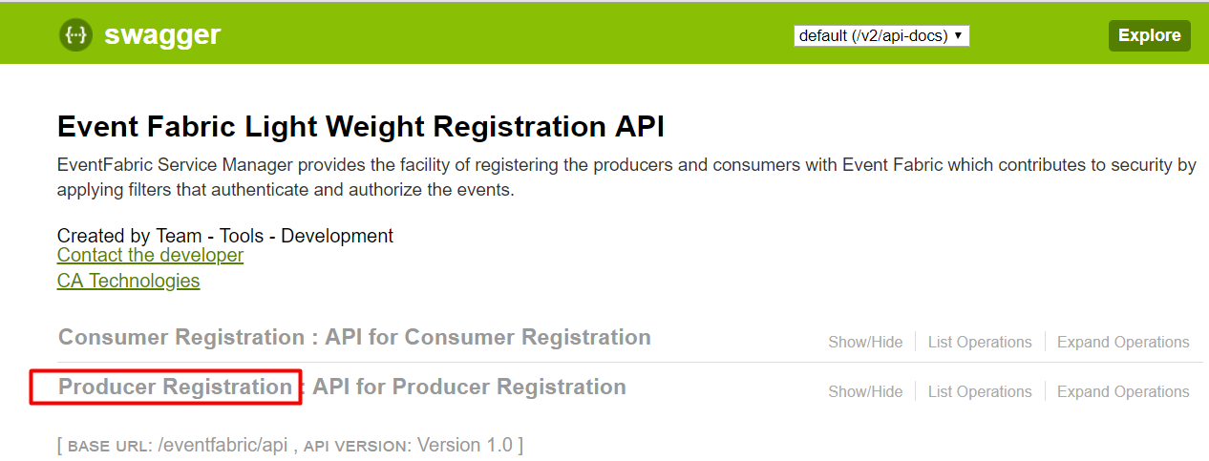
* Click on **POST**request as shown below:  
  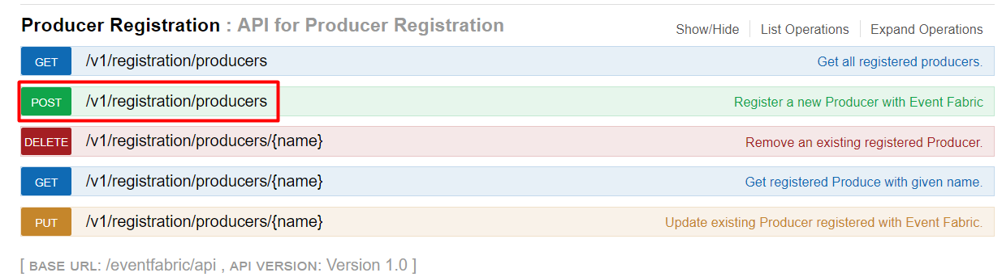
* Now under **Parameters**section enter the JSON as shown below:  
  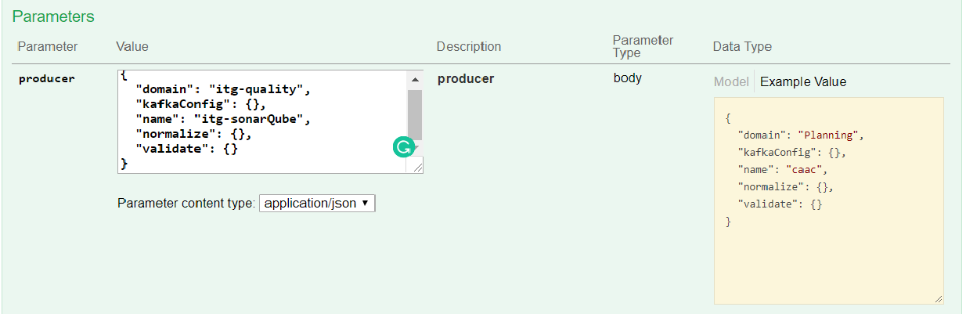  
  As you see in the image above, the **domain**name could be anything but it is recommended to give some meaningful name. For example, if the producer is of type Source Code such as GIT, Bitbucket, etc then domain name should represent the same. In our case, as we want to register **SonarQube**as a producer I have given the name as **itg-quality**(Please note that this is not the name we are using, I am showing it here for demo purpose). The second parameter which needs to be provided while registering the producer is the name. Again, the name could be anything you like and here I have given the name as **itg-sonarQube.**
* Once you fill-in domain name and the name parameter click on **Try it Out!**button.  
  This will create a new topic in **Kafka**with the name **itg-sonarQube**. Topic is where Kafka publishes all the events generated by the registered tool.

Step 2: After registering the producer one can register as many consumers you like. For consumer registration follow the process described below (Images will be similar to as shown above):

* Visit **http://service-manager-test.caas-dev.ca.com/eventfabric/api/swagger-ui.html**
* Click on **Consumer Registration**link
* Click on **POST**request
* Under the **Parameters**section enter the payload to register the consumer  
  In our case, the consumer is SonarQube controller. Thus we need the consumer URL and the domain name we have used while registering SonarQube as a producer in the previous step. The request body looks something as shown below:  
  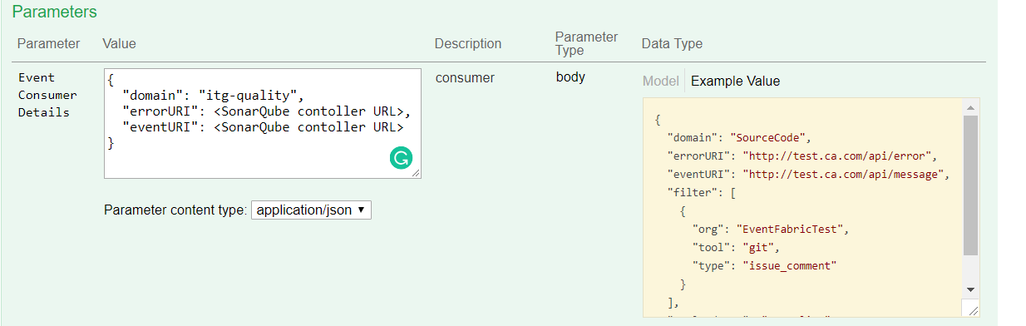
* Click on **Try it Out!**button to send the post request

**NOTE:**In both the steps above after clicking on **Try it Out!**button you should receive a response with code 200.

Step 3: After successful registration of a producer and consumer you need to add the Event-Fabric webhook to your project. For example, after executing the above process one needs to add the http://ingest-eventfabric-test.caas-dev.ca.com/receiver/api/v1/**itg-sonarQube**as webhook in the tool.